Ajinomoto Philippines – IT Landscape & Integration Requirements
Workshop Session 4, IT and technical integrations · Oct 29, 2026 · @Srini

1. Workshop context and scope
All of APC's application interfaces run through one middleware, DataSpider, with SAP S/4HANA at the centre. The new procurement platform can therefore plug into the existing hub rather than adding point-to-point links. It should read quality results from WMS rather than integrating with LIMS directly.
Item | Detail
Client | Ajinomoto Philippines Corporation (APC), Project Beacon
Session | Workshop Session 4 – IT and technical integrations, 29 Oct 2026 (after the KPI part)
Durvah team | Kishore, Sunit Nighut
Ajinomoto | Chris Ballesteros (Beacon lead), IT (Darylann Malabo, Joannacris Escanilla, Johnleonard Salvadico, Nhorien Tayco), procurement, finance
Inputs | Session transcript and APC's “IT Applications Architecture” diagram
Related | KPI reports and dashboards (same session, separate document); all earlier workshop documents
Next | Durvah presents its consolidated understanding from Day 1 to date on 30 Oct

2. Current system landscape
SAP S/4HANA on Azure is the system of record for finance, sales, purchasing and inventory. DataSpider links it to Jedox, Infor WMS and the HTMS sales portal, while Concur, Citi Bank, HR and the sales analytics stack connect to SAP directly.
Existing system landscape (APC IT Applications Architecture)
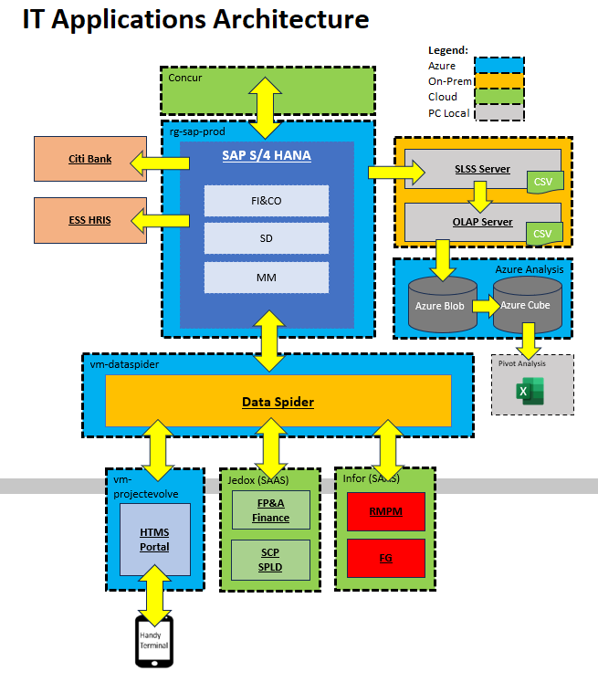
Source: APC IT, shared during Workshop Session 4, 29 Oct 2026.
Annotated view, the same landscape redrawn with interface purposes and the planned LIMS:
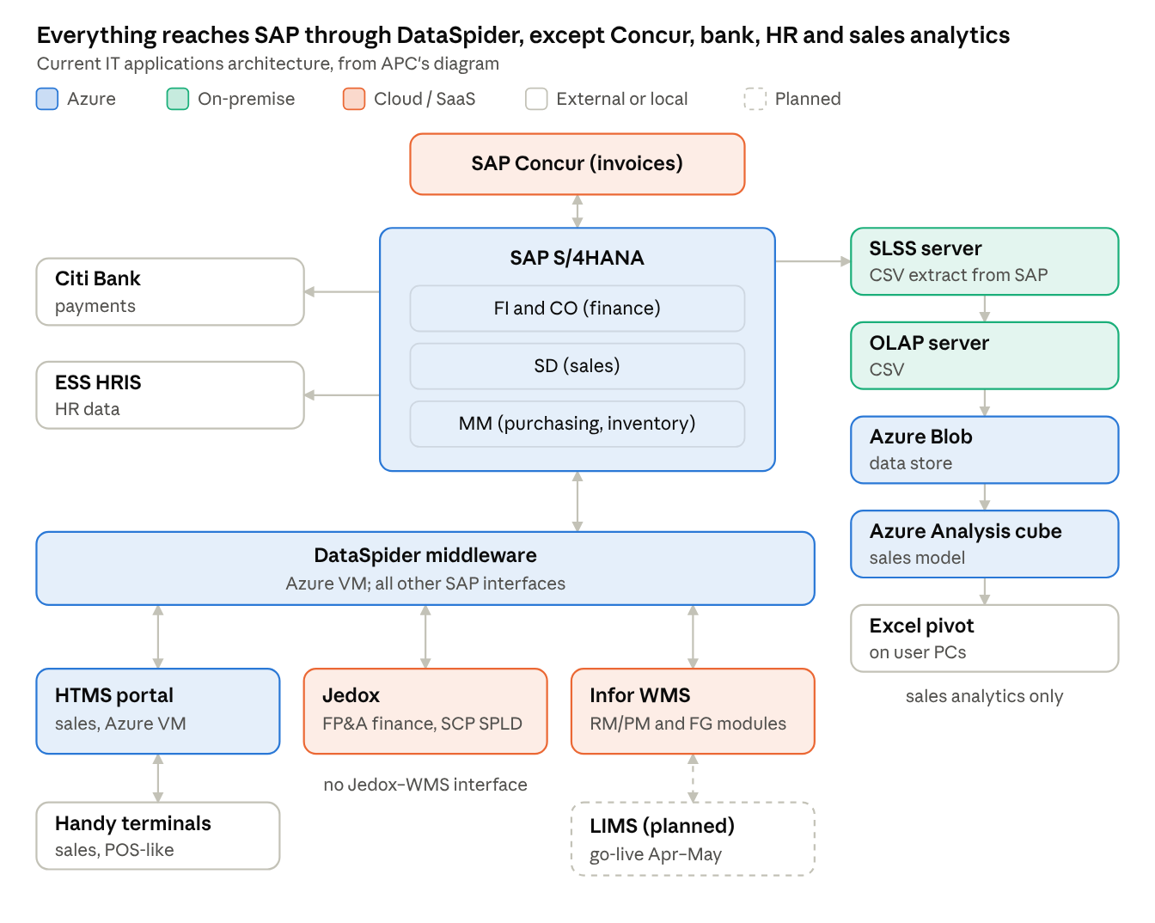
Current IT applications architecture · redrawn from APC's diagram
LIMS is not yet live. It will update WMS, and through WMS's existing DataSpider link the results can reach SAP and the new platform.

3. Current integrations and notes
SAP connects directly to Concur, Citi Bank, ESS HRIS and the sales analytics servers. Every other application reaches SAP through DataSpider.
# | From | To | Route and method | Purpose
I1 | SAP S/4HANA | SAP Concur | Direct, two-way; ABAP batch program posts invoices | Invoice capture (OCR) and matching in Concur; posting status back to SAP. Payment status not returned
I2 | SAP S/4HANA | Citi Bank | Direct, outbound | Payments
I3 | SAP S/4HANA | ESS HRIS | Direct, outbound | HR / employee data
I4 | SAP S/4HANA | SLSS and OLAP servers (on-premise) | CSV extracts | Sales data for analysis
I5 | OLAP server | Azure Blob, then Azure Analysis cube | File load | Sales analytics; Excel pivot analysis on user PCs
I6 | SAP S/4HANA | Jedox (SaaS: FP&A finance; SCP / SPLD supply planning) | DataSpider, two-way | Sales, vendor master and finance data for planning and budgeting
I7 | SAP S/4HANA | Infor WMS (SaaS: RM/PM and FG warehouses) | DataSpider, two-way | PO to WMS; receipts, transfers, issues and shipments to SAP
I8 | SAP S/4HANA | HTMS portal (Azure VM) and handy terminals | DataSpider, two-way | Sales terminals (POS-like)
I9 | Jedox | Infor WMS | None (manual) | Not integrated
I10 | LIMS (planned) | Infor WMS | Planned | Lab results (pass/fail) to WMS; integration is in the LIMS project scope
Notes from the discussion
- Hosting: SAP, DataSpider, the HTMS portal and the Azure analytics run on Azure. Concur, Jedox and Infor are cloud/SaaS. The SLSS and OLAP servers are on-premise.
- API capability:
  - SAP supports REST APIs and file interfaces, though custom APIs may be needed through APC's SAP vendor.
  - Jedox has an existing API connection.
  - Infor WMS is expected to support APIs.
  - LIMS API capability is unknown.
- Support: APC IT builds ABAP integrations in-house. Third-party vendors support WMS and other systems.
- LIMS: deployment is targeted for April–May next year. APC procurement has asked to join the LIMS project meetings but has not been invited.
- Invoices: SAP Concur reads scanned invoices by OCR and matches them to PO and GR, and approved invoices post to SAP by a batch job.
- Analytics: Azure analytics covers sales only. Planning has a separate Power BI dashboard.
- Other tools:
  - Zoho Sign was adopted this week for e-signature.
  - There is no CRM; sales is evaluating Salesforce and Zoho, and sales has a customer portal.
  - The only single sign-on today is Microsoft (Outlook); SAP and Zoho are not on SSO.

4. Pain areas
The landscape is integrated for transactions but not for supplier collaboration or procurement analytics, which still run on email and Excel.
# | Pain area | Impact
P1 | No system for supplier collaboration (onboarding, sourcing, PO acknowledgement, ASN, NCR) | Email and Excel across all supplier processes
P2 | Jedox and Infor WMS not integrated | Planning and warehouse data reconciled by hand
P3 | Concur returns posting status but not payment status | Procurement and suppliers cannot see what is paid
P4 | Analytics stack (SLSS, OLAP, Azure cube) covers sales only; planning uses a separate Power BI | No procurement analytics; scattered reporting tools
P5 | LIMS integration design unknown to procurement; procurement not in LIMS meetings | Risk that quality data cannot reach the new platform in the needed form
P6 | API readiness of Jedox, WMS and LIMS not confirmed; SAP may need custom APIs | Integration effort and vendor dependency uncertain
P7 | Planning system future (Jedox replacement or SAP planning) undecided | Integration design may have to change
P8 | No SSO beyond Microsoft | Separate logins; weaker access control

5. To-be target architecture
The proposed design adds the procurement platform as one more system on the DataSpider hub, so there are no new point-to-point links.
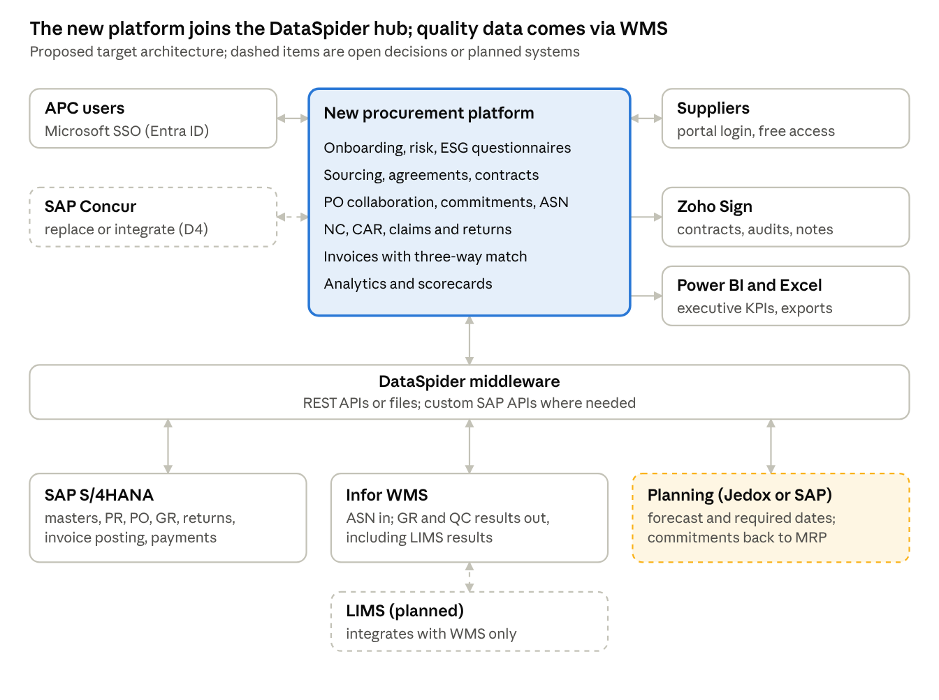
Proposed target architecture · platform on the DataSpider hub
What changes:
- Users: internal users sign in through Microsoft SSO, and suppliers log in to the portal at no cost to them.
- SAP: stays the record for masters, PO, GR, returns, invoice posting and payments.
- WMS: receives supplier ASNs and returns receipt, inspection and LIMS results, so the platform needs no direct LIMS link.
- Planning: the planning engine (Jedox or SAP, still to be decided) exchanges forecasts, required dates and commitments.
- Still open: Concur either stays and is integrated, or is replaced by platform invoicing. PO creation can sit in SAP or the platform (see section 7).

6. Integration and technical requirements
Fourteen technical requirements came out of this part of the session. Field mapping, validations and touch points will be detailed during implementation. Priorities are Durvah's proposal for Ajinomoto to confirm.
ID | Area | Requirement | Priority
IT-01 | Middleware | All platform–SAP–WMS–planning interfaces run through DataSpider using REST APIs or file transfer | Must
IT-02 | SAP master data | Vendor master create/change/block out to SAP; material, plant and payment-terms masters in from SAP | Must
IT-03 | SAP PR and PO | PRs in from SAP (or the planning engine); POs created in SAP or the platform (decision pending) and synced both ways, including change orders and schedule lines | Must
IT-04 | Agreements | Price agreements / outline agreements out to SAP | Must
IT-05 | Goods receipt and returns | GR, returns against PO and GR, and stock status in from SAP or WMS per PO line | Must
IT-06 | WMS ASN | Supplier ASN out to Infor WMS via DataSpider; receipt and inspection results back | Must
IT-07 | Quality results | LIMS pass/fail and COA references obtained through WMS, not by a direct LIMS interface | Must
IT-08 | Planning | Forecast and required dates in from the planning system (Jedox or SAP); supplier commitments out | Must
IT-09 | Invoicing | Either replace Concur with platform invoicing (OCR, two- and three-way match, posting to SAP) or integrate Concur status into the platform; payment status from SAP | Must – option to decide
IT-10 | Single sign-on | Internal users sign in with Microsoft (Entra ID) SSO; suppliers use portal credentials with strong authentication | Must
IT-11 | E-signature | Integrate Zoho Sign (or native e-signature) with audit trail | Should
IT-12 | Analytics export | Data available to Power BI and Excel; optional feed to the Azure analytics stack | Should
IT-13 | Hosting and data | Cloud SaaS acceptable; APC data stored in agreed regions; AI features controlled by APC | Must
IT-14 | ESG data | Supplier ESG questionnaires in the portal; external ESG data feeds optional, given limited coverage of local suppliers | Could

7. Design decisions
# | Topic | Status | Decision or options
D1 | Integration route | Agreed in principle | Use DataSpider for all new interfaces; fewer applications and links
D2 | LIMS data | Agreed in principle | Take lab results from WMS, which LIMS will update; no direct platform–LIMS link
D3 | PO creation | Open | Keep PO creation in SAP and publish to the portal, or create in the platform and post to SAP. APC to check legal and regulatory PO format requirements
D4 | Invoicing | Open | Move invoice capture and matching from Concur to the platform, or keep Concur and integrate status
D5 | MRP and allocation | Open | SAP vs Jedox (see Sessions 2 and 3); depends on the planning-system roadmap
D6 | SSO | Agreed in principle | Microsoft SSO for internal users; licences assigned per user account

8. Open questions
# | Question | For
Q1 | Do Jedox, Infor WMS and LIMS support REST APIs, and which endpoints exist today? | IT with vendors
Q2 | Will LIMS send pass/fail and COA references to WMS automatically, at batch and GR level? | LIMS project team
Q3 | Can procurement and Durvah join the LIMS project meetings? | Chris Ballesteros, LIMS team
Q4 | Which planning system will replace Jedox next year, and when? | IT, planning
Q5 | Are there legal or regulatory requirements on PO format and issuance that decide where POs are created? | Procurement, legal
Q6 | Will finance move invoicing off Concur, or keep it? | Finance
Q7 | How is the existing HCM interface built, and can it serve as a reference pattern? | IT
Q8 | Who supports DataSpider, and is there capacity for new interfaces? | IT

9. Action items
Seven actions came out of this part of the session. Confirming API readiness (A1) and the LIMS–WMS design (A2) unblock the integration design. Owners are proposed from the discussion; please confirm.
# | Action | Owner | Due | Status
A1 | Confirm API capability and existing interfaces for Jedox, Infor WMS and LIMS | IT with vendors | Next week | Open
A2 | Share the LIMS project scope, timeline and integration design; arrange procurement and Durvah attendance | Chris Ballesteros, LIMS team | Next week | Open
A3 | Share the IT applications architecture source file and interface list | IT | This week | Open
A4 | Share the planning Power BI dashboard (session with Rachelle) | Planning (Rachelle) | 30 Oct, 3 pm | Open
A5 | Confirm the planning system roadmap (Jedox replacement or SAP) | IT, planning | Next week | Open
A6 | Check legal and regulatory requirements on PO format and issuance | Procurement / legal | Next week | Open
A7 | Present the consolidated understanding (Day 1 to date) and the proposed target architecture | Durvah (Kishore, Sunit) | 30 Oct | Open

